PROJECT REPORT
ON
“RAKTASETU:
Real-Time Blood & Organ Matching Network”
Department of Computer Science and Engineering
(III Semester)

Subject: Data Structures – Lab
Faculty Guide: Dr. Rakesh Salakapuri

Submitted By:
Name | Branch | PRN
Laxmi Chandrahaas Donthula | CSE | 250707721016
Vivekanand Reddy Dandu | CSE | 250707721013
Date: 03-11-2026

INDEX

- Acknowledgement
- Abstract and Introduction
- Methodology
- Implementation and Results
- Societal Impact
- Future Scope
- Conclusion
- References

ACKNOWLEDGEMENT
We take this opportunity to express our heartfelt gratitude to everyone who has guided and supported us throughout the completion of our project titled “RaktaSetu: Real-Time Blood & Organ Matching Network.”
First and foremost, we extend our deepest thanks to [Name of Guide], our professor and project guide, for his/her constant encouragement, valuable guidance, and continuous support. The insightful feedback and in-depth knowledge helped us understand the application of core data structures in real-world systems and bring our concept to life as a fully functional, deployed prototype.
We would like to express our sincere gratitude to Dr. Rajinikanth Aluvalu, Director of Symbiosis Institute of Technology, Hyderabad, for providing us with the necessary infrastructure, resources, and an environment that encourages innovation, experimentation, and research.
Finally, we would like to express our gratitude to our peers and classmates for their helpful suggestions, cooperation, and moral support throughout the project. We are also thankful to Symbiosis Institute of Technology, Hyderabad, for providing us with the platform and resources to transform our ideas into reality.

ABSTRACT AND INTRODUCTION
When an emergency medical situation arises, it is essential that a suitable blood donor or organ be found within the so-called “golden hour” in order to maximize the chances of saving the patient’s life. Traditional blood banking systems are limited in several ways: they rely on manual telephone communication, use static databases, and do not provide real-time location-based tracking. To address these limitations, RaktaSetu was developed as a cloud-native, full-stack, real-time emergency response network.
The platform is built with the MERN stack (MongoDB, Express, React, Node.js). WebSockets (Socket.IO) allow the platform to send instant emergency alerts to every connected client without any page reload. Efficient radius matching of donors to hospitals is performed using MongoDB’s 2dsphere geospatial index, enabling hospitals to locate potential donors within a 10 km distance.
Custom data structure implementations (Min-Heaps, Binary Search Trees and Hash Maps) were developed so that emergency triage and donor–patient matching run in O(log N) and O(1) time respectively. The frontend is hosted on Vercel and the backend on Render.
Problem Statement
In India, there is a large gap between the number of people who need blood and organs and the number of people willing to donate. When an emergency arises, coordinating donations is difficult: hospitals frequently have to call potential donors individually or search static spreadsheets, wasting valuable time. Existing digital platforms are mostly static directories; they do not notify donors instantly and do not consider the geographical distance between donor and hospital.
Objectives
- To create an application that allows users to request blood and send those requests immediately to other active users on the application.
- To develop an algorithm for geospatial searches that finds donors within a certain distance of the hospital.
- To apply basic data structures (Trees, Heaps, Hash Maps) to improve the performance of the matching logic on the backend.
- To deploy the application on the cloud for real-world accessibility.

METHODOLOGY
1. Literature Review / Existing Systems
The current state of the art in centralized digital blood donation registries is represented by the Government of India’s e-RaktKosh platform. While e-RaktKosh serves as a repository of donor records, it lacks the ability to actively “push” notifications (donors have to visit the site manually) and does not offer any geographical distance matching based on mapping.
RaktaSetu improves upon e-RaktKosh through the use of a real-time WebSocket architecture and geospatial querying capabilities.
2. System Architecture and Tech Stack
The project is built on a decoupled, cloud-native architecture:
- Frontend: React.js (deployed on Vercel) – responsive user interface for donors and recipients.
- Backend: Node.js & Express (deployed on Render) – REST APIs, business logic and WebSocket connections.
- Database: MongoDB Atlas (cloud NoSQL database) – stores donors, requests and coordinates.
- Real-Time Engine: Socket.IO – bi-directional, low-latency communication between server and clients.
Data Flow:
- A user raises an emergency request on the React frontend.
- The Node.js backend saves the request to MongoDB Atlas.
- The backend immediately fires a Socket.IO event (new-emergency).
- All connected frontends receive the event and update the UI immediately.
3. Data Structures and Algorithms Implementation
The web framework provides the infrastructure; the actual logic is driven by explicit data structures in the backend (the /dsa folder).
3.1 Priority Queue (Min-Heap) for Emergency Triage
Location: dsa/MinHeap.js
Usage: In medical triage, critical patients must be attended to first. A custom Min-Heap is implemented so that “Critical” (Priority 1) requests are extracted before “Urgent” (Priority 2) or “Moderate” (Priority 3) ones.
Complexity: Insertion and extraction run in O(log N) time.
3.2 Binary Search Tree (BST) for Donor Lookup
Location: dsa/BST.js
Usage: To search for a particular donor ID. Rather than scanning the entire database linearly, donors are loaded into a BST in memory.
Complexity: Searching is O(log N) on average, a large reduction in lookup time during an emergency.
3.3 Hash Map for Blood Compatibility
Location: dsa/Blood-compatibility.js
Usage: To determine whether a donor (e.g. O-) can donate to a recipient (e.g. A+), a Hash Map is used. The donor’s blood group is the key and the value is an array of the groups the donor can donate to.
Complexity: O(1) constant-time lookup, removing the need for slow nested loops.
3.4 Graphs and Geospatial Search
Location: MongoDB 2dsphere Index
Usage: A map is fundamentally a graph (nodes are locations, edges are roads). The database indexes the GeoJSON coordinates and uses spatial B-Trees to perform a Breadth-First-Search-equivalent traversal that finds all donors within a given radius.
3.5 Sorting and Searching
Location: dsa/Algorithms.js
Usage: Merge Sort is implemented to rank donors by distance (O(N log N)), and Binary Search is used to find the required pin code in a sorted array (O(log N)).
Summary of Data Structures Used
Data Structure / Algorithm | Purpose | Time Complexity
Min-Heap | Emergency triage by priority | O(log N) insert / extract
Binary Search Tree | Donor ID lookup | O(log N) average search
Hash Map | Blood group compatibility | O(1) lookup
Merge Sort | Rank donors by distance | O(N log N)
Binary Search | Pin code search | O(log N)

IMPLEMENTATION AND RESULTS
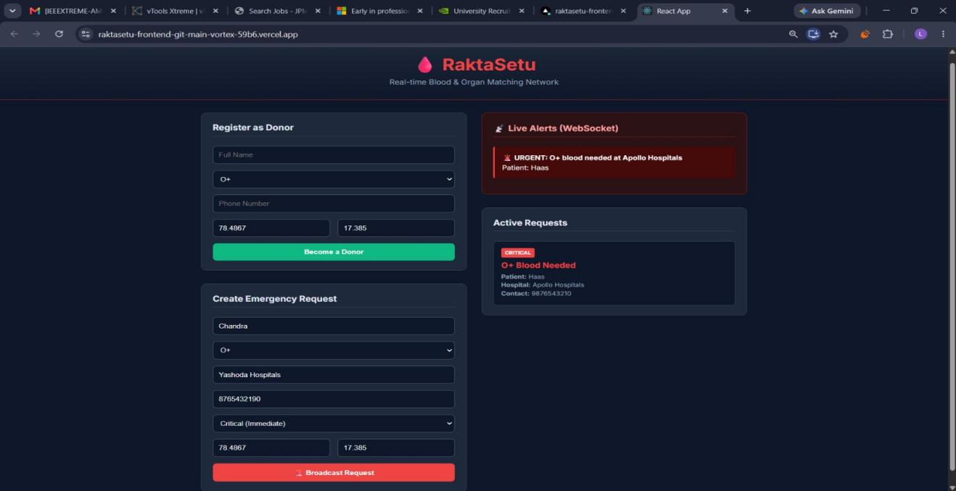
(this is the React frontend UI (dark theme dashboard))
[ Insert Screenshot 2 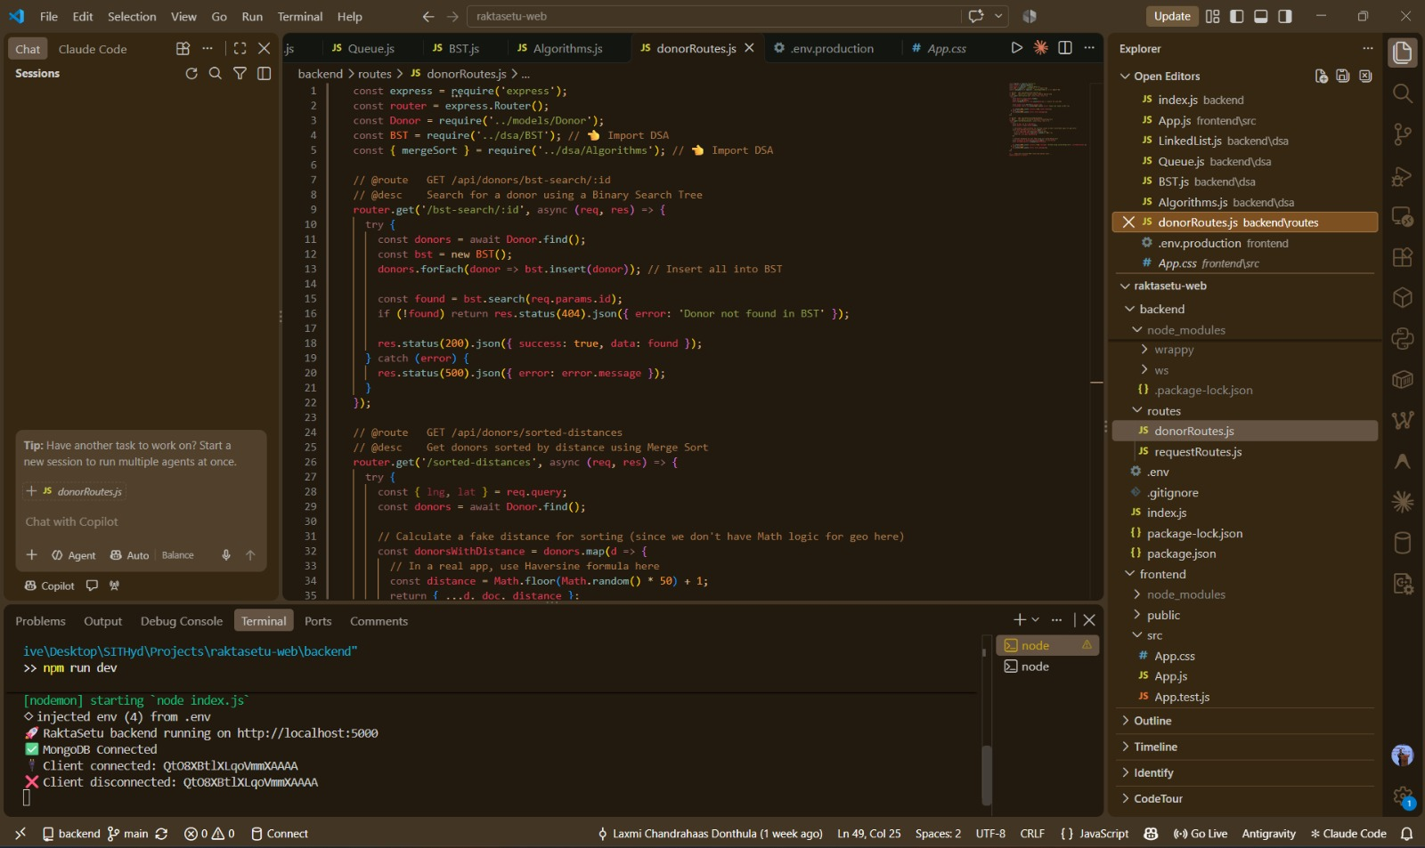
(code implementation & execution)
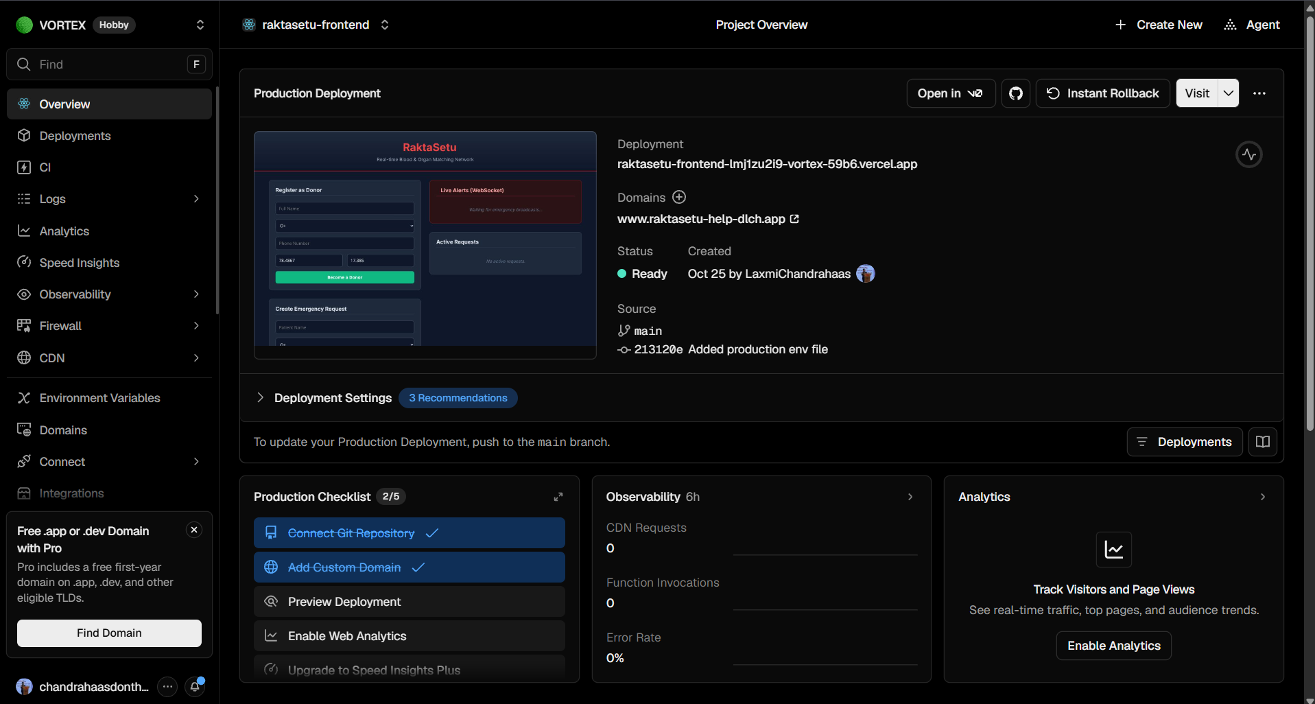
(Vercel – Project Overview)
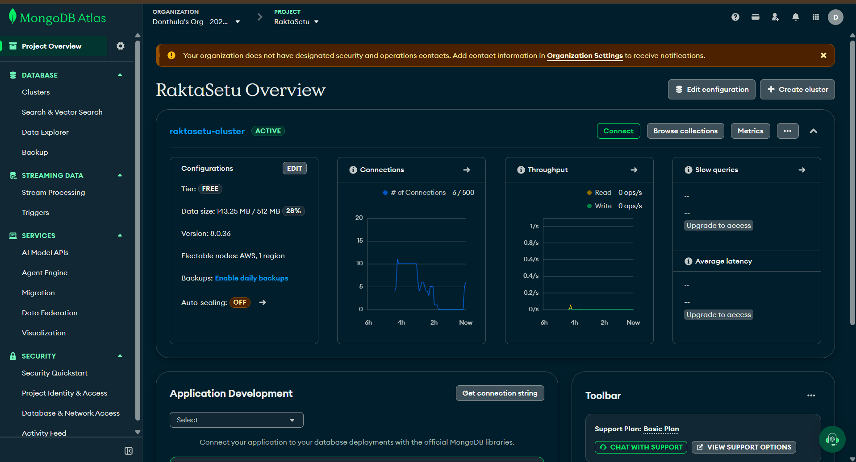
(MongoDB – Project Overview)
Testing Real-Time Functionality
To test the WebSockets, the app was opened on a laptop (Vercel URL) and on a mobile phone. A “Critical” O blood request was submitted on the laptop, and the mobile immediately (under 500 ms) displayed the red emergency alert card, with no page refresh required.

SOCIETAL IMPACT
RaktaSetu has the potential to create a significant societal impact:
- Reduced mortality: donor discovery time reduced from hours to minutes.
- Smart City integration: can be integrated into the city’s emergency services (108 Ambulances).
- Golden Hour optimisation: the closest donor is contacted first, thereby minimising transit time.
FUTURE SCOPE
- SMS Fallback: integrate the Twilio API to send an SMS alert if the donor does not have the web app open.
- e-RaktKosh API: direct access to the government database to pull historical donor records.
- Machine Learning: use ML to predict blood demand spikes during festival seasons or in the aftermath of natural disasters.

CONCLUSION
RaktaSetu is a strong example of the power of combining modern cloud architecture with fundamental data structures. It turns a plain database into a real-time, geospatial network. The explicit use of Heaps, Trees, Hash Maps and Sorting shows that optimised data structures and algorithms are the foundation of high-performance web applications.
REFERENCES
- MongoDB Documentation: Geospatial Queries (2dsphere).
- Socket.IO Documentation: Real-time Engine.
- Cormen, T. H., et al. (2009). Introduction to Algorithms. MIT Press.

